COMMON COUNCIL February 12, 2018
The Common Council of the City of Wabash met in the Council Chambers of the City Hall, Monday, February12, 2018 in regular session, The meeting was called to order by Mayor Long who presided, and the Pledge of Allegiance was given in unison.
Pastor Jonathon Cornell of the Presbyterian Church gave the prayer.
The roll was answered by 6 members. Council Member Greene was absent.
The minutes of the meeting held February 12, 2018 were approved as circulated. Council Member Adams made a motion to accept the minutes. Council Member Shelley seconded the motion. On call of the roll the vote was as follows:
6 Ayes
Motion Carried
NEW BUSINESS:
Compliance with Statement of Benefits (Real Property) — Advanced AG Resources. Robert Hettmansperger was present to answer any questions. Council Member Dillon made a motion to accept the Compliance with Statement of Benefits (Real Property) — Advanced AG Resources. Council Member Corn seconded the motion. On call of the roll the vote was as follows:
6 Ayes
Motion Carried
General Ordinance No. 1, 2018 — Establishing Rules and
Regulations Regarding Pawnbrokers, Secondhand Dealers, Precious Metals and Stone Dealers, and Valuable Metals. Chief Bruss was present and explained the need for this Ordinance. Council Member Figert made a motion to accept General Ordinance No. 1, 2018 — Establishing Rules and Regulations Regarding Pawnbrokers, Secondhand Dealers, Precious Metals and Stone Dealers, and Valuable Metals, Council Member Shelley seconded the motion. On call of the roll the vote was as follows:
6 Ayes
Motion Carried
General Ordinance No. 2, 2018 — Establishing Rules and Regulations Regarding Transient Merchants, Peddlers or Pledger. Chief Bruss was present and explained the need for this Ordinance, Council Member Figert made a motion to accept General Ordinance No. 2, 2018 —
Establishing Rules and Regulations Regarding Transient Merchants, Peddlers or Pledger. Council Member Adams seconded the motion. On call of the roll the vote was as follows:
6 Ayes
Motion Carried
ADJOURN:
There being no further business, the meeting was ad'ourned.
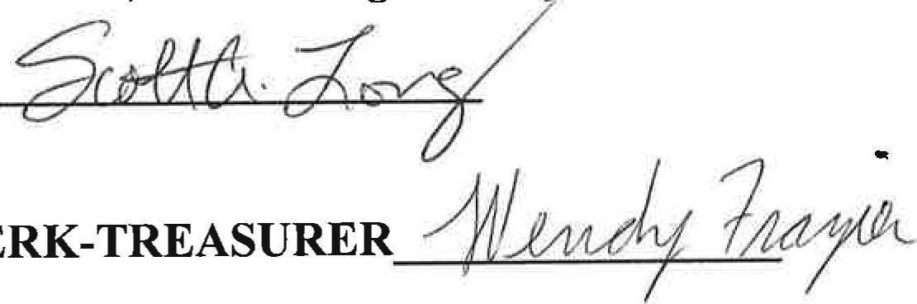
SCOTT LONG, MAYOR
FRAZIER,
CLERK-TREASURER
ATTEST: WENDY

