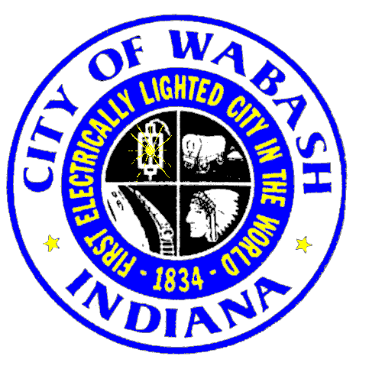

PUBLIC HEARING

CITY COUNCIL MEETING

Monday, June 23, 2025

CITY HALL CHAMBERS
6 P.M.
Pledge of Allegiance
Prayer – Keith Allen, Light City Church

AGENDA
- Roll Call
- Minutes of June 9, 2025, Meeting

OLD BUSINESS
- Second Reading of General Ordinance No. 7, 2025 Being an Ordinance Amending Chapter 10, Article 4, Regarding the Enforcement of the Wabash Historic Preservation Ordinance
NEW BUSINESS
- Veregy Update
- Resolution Number 7, 2025 A Confirmatory Resolution of the Common Council of the City of Wabash, Indiana Declaring an Economic Revitalization Area
- Update of New Tax Abatement Scoresheet – Tenille Zartman, Grow Wabash County
- Resolution No. 8, 2025 A Resolution of the Common Council of the City of Wabash, Indiana Authorizing the Transfer of Property to the Wabash County Business Alliance Foundation, Inc., A 501c3 Not for Profit Entity
- Request for Tax Abatement – Plumb Square LLC, 1450 First Street Real Estate

OTHER BUSINESS

QUESTIONS FROM THE AUDIENCE

REPORTS FROM LIAISON APPOINTMENTS

REPORTS FROM DEPARTMENTS

TITLE VI OR ADA COMMENTS OR COMPLAINTS

NEXT MEETING
Our next meeting is Monday, July 14, 2025, at 6:00 p.m.

ADJOURN
The City of Wabash desires to make reasonable accommodations to persons with handicaps or disabilities in order that all persons may fully participate in Public Meetings. In that regard, if you need reasonable accommodations to attend and participate in a public meeting, you are requested to contact Human Resources, ADA Coordinator, Wabash City Hall, 202 South Wabash Street, Wabash, IN, 46992, (260) 563-4171, between 8 AM and 4 PM at least 24 hours prior to the meeting. Please indicate the accommodation requested and every reasonable effort will be made to comply with your request. Translators are available at public meetings upon prior request.

