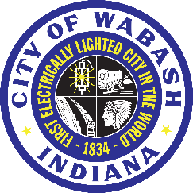 From Mayor Scott Long
Words Matter
In our great community of Wabash, where we know each other by name, and where often we know who's related to whom, the words we use carry more weight than we realize. Our words are powerful and impactful.
We’re in a microwave era of communication; words travel as fast as a snap of a finger. Whether it’s a comment on social media, a post in a community forum, or a conversation at the grocery store, our words have the power to shape how we see each other, and how others see our city, and even how we move forward together.
Our conversations do not just disappear into thin air. Hitting the delete button doesn’t erase our words. Our words land on the screen of a potential new resident, a future small business, or an investor trying to decide whether or not to invest here in Wabash.
Every comment we make, each conversation we’re in, a post we create on social media, every last word speaks volumes about you, me, and the community we live in.
Wabash has so much to offer and to be proud of. We have strong schools, wonderful amenities like beautiful parks, historic architecture, small businesses, arts and culture, and community members who consistently step up for one another. You see, focusing on what is good helps strengthen our community. When we speak with purpose, kindness, and clarity, we build community trust. When we lead with respect, even in disagreement, we prove that Wabash is not just a place to live or work, but a place that values your worth.
Of course, this doesn’t mean we ignore challenges. It means we address challenges in a constructive and respectful manner. It means working with me for solutions, not just criticisms. It means remembering that behind every screen is a neighbor, a student, a volunteer, a business owner, or someone with a stake in the same community and future that we all share.
So, I ask, if someone’s first impression of Wabash was based on my words, would it make them want to be part of our community? Because someone is always watching, always listening, always forming an opinion not just about what we say, but about who we are. And I believe Wabash is a community worth speaking well of.
— Mayor of Wabash, Indiana

