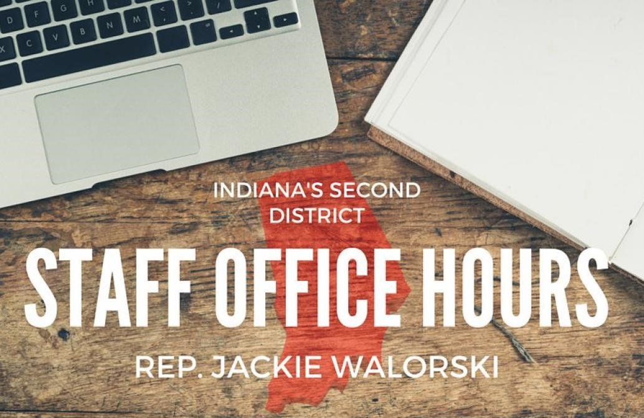

“Congresswoman Jackie Walorski's staff will be holding upcoming office hours to assist constituents with casework and official business.
Residents who cannot attend the listed office hours are encouraged to contact (574) 204-2645 to schedule an appointment.”

