COMMON COUNCIL January 11, 2021
The Common Council of the City of Wabash met in the Council
Chambers of the City Hall and held a tele-conference Council Meeting, Monday, January 11, 2021 in regular session. The meeting was called to order by Mayor Long who presided, and the Pledge of Allegiance was given in unison.
Reverend Carder of Whites Residential gave the prayer.
The roll was answered by 7 members.
The minutes of the meeting held December 14, 2020 were approved as circulated. Council Member Adams made a motion to accept the minutes. Council Member Brewer seconded the motion. On call of the roll the vote was as follows:
7 Ayes
Motion Carried
NEW BUSINESS:
Council Member Dillon nominated Council Member Burnsworth to be the new City Council President. Council Member Bonfitto seconded the motion. Council Member Monroe made a motion to close nominations. All were in favor of closing the nominations.
Mayor Long swore in Probationary Patrolman Gareth L. Monroe.
Attorney Lehman discussed and explained the need for Council to wave a conflict of interest for new Council Member Weaver.
The Investment Policy was presented. Council Member
Burnsworth made a motion to accept and to keep the Investment Policy as is. Council Member Weaver seconded the motion. On call of the roll the vote was as follows:
7 Ayes
Motion Carried
OTHER BUSINESS:
Mayor Long gave an update on the vaccine clinic
ADJOURN:
There being no further business, the meeting was adjourned.
SCOTT LONG, MAYOR
ATTEST:
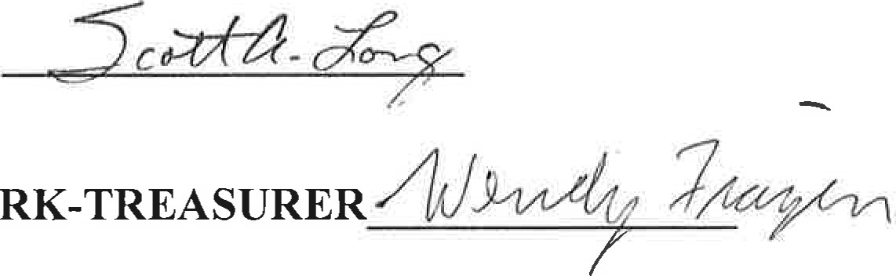
WENDY FRAZIER, CLERK-TREASURER

