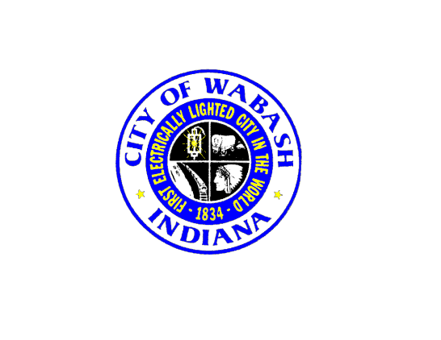
City Hall will be closed on Friday, April 19th in observance of Good Friday. We will reopen on Monday, April 22nd, 8:00 AM

Thank You

