COMMON COUNCIL May 29, 2018
The Common Council of the City of Wabash met in the Council Chambers of the City Hall, Tuesday, May 29, 2018 in regular session.
The meeting was called to order by Mayor Long who presided, and the Pledge of Allegiance was given in unison.
Pastor Brandon Eaton of Wabash Friends Church gave the prayer.
The roll was answered by 6 members. Council Member Figert was absent.
The minutes of the meeting held May 14, 2018 were approved as circulated. Council Member Adams made a motion to accept the minutes. Council Member Shelley seconded the motion. On call of the roll the vote was as follows:
6 Ayes
Motion Carried
NEW BUSINESS:
Mayor Long swore in Colton Ringel as a Probationary Firefighter/EMT.
Mayor Long swore in Chad Galligan as Captain for the Wabash Police Department.
Mayor Long swore in Andrew Johnson as Sergeant for the Wabash Police Department.
Susan Stewart presented Ron Metz, Erika Milam and Grant Keaffaber of Bucheri, McCarty & Metz and Tom & Melanie Boyll of
The Crow's Nest with Historic Preservation Awards. Matt Gadus of
Rock City Lofts was not present, Susan spoke kind words on his behalf.
Resolution No. 5, 2018 — Tax Abatement for Kim Oanh,
Vu Jimmy Nguyen, NHA Ngoc Tran. Kim Oanh was present to answer any questions. Council Member Adams made a motion to accept Resolution No. 5, 2018 — Tax Abatement for Kim Oanh, Vu Jimmy Nguyen, NHA Ngoc Tran. Council Member Shelley seconded the motion. On call of the roll the vote was as follows:
6 Ayes
Motion Carried
Compliance with Statement of Benefits (Personal Property) — B. Walters/Scott Buehrer. Scott Buehrer was present to answer any questions and Keith Gillenwater spoke on behalf of B. Walters and the abatement. Council Member Dillon made a motion to accept the Compliance with Statement of Benefits (Personal Property) — B.
Walters/Scott Buehrer. Council Member Shelley seconded the motion. On call of the roll the vote was as follows:
6 Ayes
Motion Carried
Tina Henderson of Mendenhall & Associates gave an update on the Eagles Theater Project.
ADJOURN:
There being no further business, the meeting was adjourned.
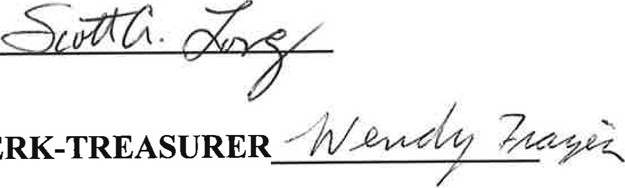
SCOTT LONG, MAYOR
FRAZIER,
CLERK-TREASURER
ATTEST: WENDY

