BOARD OF PUBLIC WORKS AND SAFETY NEETING ivm•WTES
CITY HALL CHAIVBERS
THURSDAY, FEBRUARY 21, 2019
4:00 P.M.
Present: Mayor Scott Long; City Attorney Randi Zimmerman, and Board Members Todd Titus and Jim Reynolds
Department Heads present: Assistant Police Chief, Bob Pilgrim; Fire Chief Barry Stroup; Waste Water Superintendent, Bob Gray; Street Superintendent, Scott Richardson; Park Superintendent, Adam Hall; Building Commissioner, Jim Straws; Clerk Treasurer, Wendy Frazier
City Council Members Present: Eric Schoening, Doug Adams, Bob Greene

MNIJTEs
Todd Titus made a motion to accept the minutes from the February 7, 2019 meeting. Mayor Long 2nd the motion. Motion carried.
CITY CLAIMS-SEWAGE CLARYIS
Jim Reynolds made a motion to approve the claims. Todd Titus 2nd the motion. Motion Carried.

OLD BUSNESS
- Don/Peggy Fraley, 310 Euclid St. Mrs. Fraley was in attendance at the meeting. Jim Straws informed the Board that since the January decision to give Fraley's 90 days to demolish the structure, the structure caught on fire. The building has been deemed unsafe and needs to come down. The Fraley's are to get the building demolished. If nothing has been done as of April 4, the City Street Department will do the work and put a lien on the property, The Board reminded Mrs. Fraley that by April 4, the vehicles must be removed and the property cleaned up. If not, the City will also have the vehicles removed and the cost passed on to them.
Fire Chief, Barry Stroup, confirmed that they were done with the fire investigation and the Fraley' s should proceed with demolition.
Todd Titus again reiterated that the building needs to come down sooner than later but no later than April 4, 2019.
- Awarding the Miami Street Advanced LTCP Project. Keith Bryant was present and informed the Board that after reviewing the submitted bid tabulations, Ironclad, from Roanoke, Indiana, was the low bid and very close to the estimated cost. They are doing a great job with the Alena and Chestnut Street projects, Therefore, Mr. Bryant recommended to the Board that they award the bid of $1,092,791.43 to Ironclad.
Wastewater Superintendent, Bob Gray, informed the Board that this project will be paid out of the last sanitary bond because they still have money left in the fund.
Jim Reynolds made a motion to accept the United Consultants recommendation and award the bid to Ironclad. Mayor Long 2nd the motion. Motion carried.
- Betty Benson property drainage property located at the South West comer of US 24/Hwy 15 update:
Bob Gray, Wastewater Superintendent, received a report from INDOT. They checked out the problem on February 19, and said the location of the problem was not part of their property. Superintendent Gray recommend that the City take responsibility to fix the problem. If it isn't fixed the property will continue to deteriorate. Gray predicted the amount to fix the problem should be $5,000 -$7,000. The work will have to be done when the ground is frozen or dry. The Stormwater Board has quotes from Earthworks and Eads. Gray's landscaping has permits signed by the DNR that are still good and will be forwarded to the City. No action is required from the Board of Works since the process went through and was approved by the Stormwater Board.
NEW BUSBÆSS None

OTHER BUSNESS
Building Commissioner, Jim Straws, informed the Board that Code Enforcement Officer, Kipp Cantrell is in the process of creating a system to determine to what degree structures are in blighted condition. The system will be used all over Wabash so every decision will be made using the same system. This will ensure that each structure is dealt with fairly. The highest scoring structures will be dealt with first. Commissioner Straws asked the Board for their input. Mayor Long thought the proposal was a good idea and wants to implement it immediately. Mayor Long said the process will bring everything to a common playing field, aligning grades with our Codes and Ordinances.

OUESTIONS FROM THE AUDIENCE
l. Kent Mullett, neighbor to 310 Euclid Street expressed his, and his neighbors, concerns regarding the fire damaged structure. He said Fraley's have not touched the structure or vehicles except to move a lawn mower out of the structure before the fire. Mr. Mullett said he understood Fraley's had been given a letter that they had 10 days to fix the property. Jim Reynolds reminded Mr. Mullett that the Fraley's have until April 4, to fix the property.
If Fraley's haven't demolished the structure, it will come down on April 5, because the City Street Department will demolish it. Once again Mr. Mullett expressed his frustration that Fraley's will not clean any of the property up. Jim Reynolds thanked Mr. Mullett for his patience and said it will all be dealt with by April 5.
2. Bev Vanderpool, Assistant to Mayor Long, reminded everyone that this evening will be our first Evening with the Mayor, starting at 6:00 p.m. at the Wabash County Historical Museum and encouraged everyone to attend.

REPORTS FROM DEPARTMENTS
None
ADJOURN
Mayor Long made a motion to adjourn.

NEXT MEETNG
The next Board of Works meeting will be held on Thursday, March 7, 2019, at 4:00 p.m.
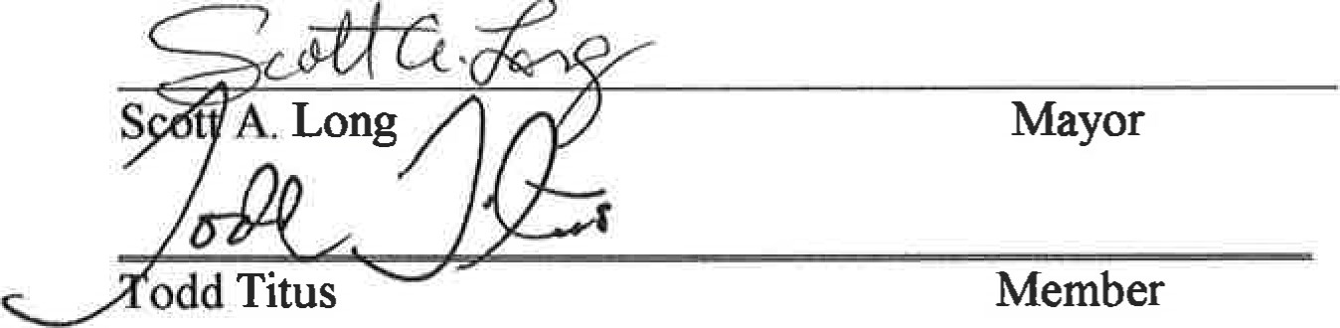
The City of Wabash desires to make reasonable accommodations to persons with handicaps or disabilities in order that all persons may fully participate in Public Meetings. In that regard, if you need accommodations to attend and participate public meeüng, you are requested to contact Human Resources, ADA Coordinator, Wabash City Hall, 202 South Wabash Street, Wabash, Indiana 46992, (260) 563-4171 between 8 AM and 4 PM at least 24 hours prior to the meeting. Please indicate the accommodation requested and every reasonable effort will be made to comply with your request.

